VED GDD

100692052

# Project overview

In this project I will create a 3d platforming game with the primary gameplay mechanic being the changing gravity. This will be a brief explanation of gameplay is only placed in this document to better explain the design choices:

* For rounded platforms such as micro-planets, moons, small asteroids, etc (dubbed **celestial platforms**) the gravity will always be perpendicular to the general surface “beneath” the player. This means that players will always move “down” towards the current celestial platform.

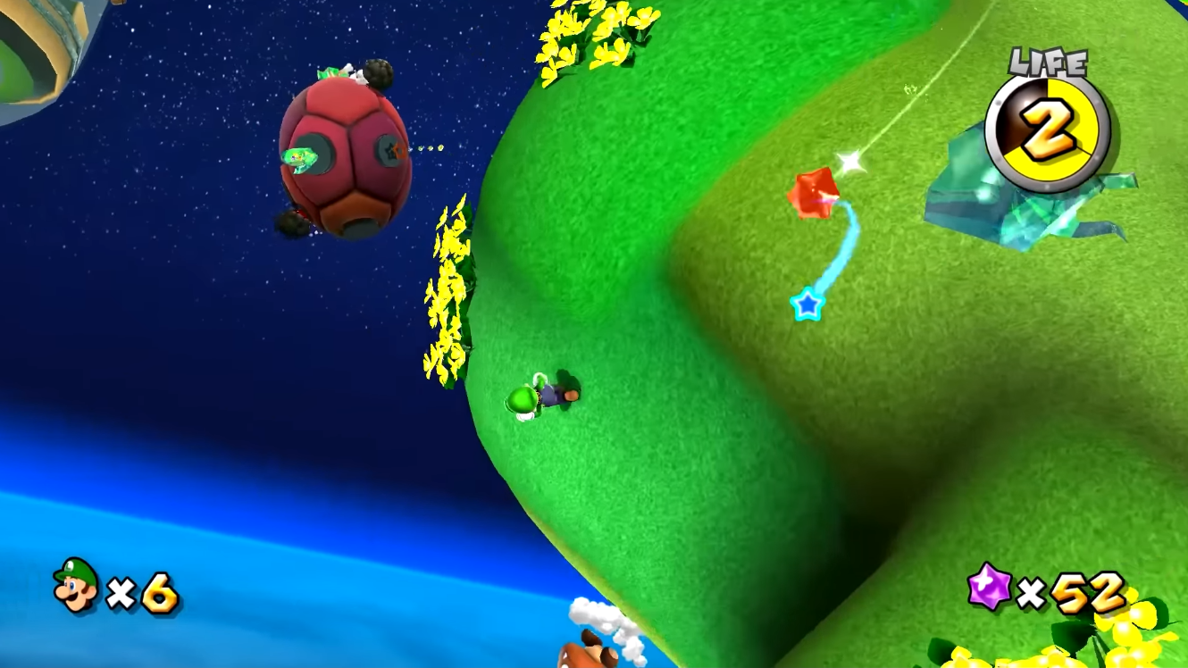

Figure - Super Mario galaxy gravity on rounded platforms

* For other platforms, with a generally flat surface, or a combination of different flat surfaces at different elevations, gravity will generally always be towards the flat surface. **Some** sections of these platforms may include parts where gravity may transition to a different direction but will always result in being in the direction of a flat surface near the player such as a wall or the ceiling of a building.

The environment will be a mix of both celestial platforms and normal flat platforms, in the form of a micro-solar system.

The main inspiration for this project is the Super Mario Galaxy series. A combination of the toy like look of Mario and similar game franchises, and the vast open-ness of space allows for an almost dream like feeling, where the player can jump between micro-planets and explore a mini solar system. I would also like to bring in the feeling of mystery and nonsensical whimsey of Alice in wonderland, where some things don’t make sense because they simply don’t have to.  
  
Here is a very rough concept of the sort of scenery I would like to create on the planets.

Figure - AI generated concept scene for the project.

Though not completely capturing what I would like, the image conveys the general idea of the sort of scenery I would like on the platforms, quite varying elevation on each of the flatter islands, to give them a rounder look akin to a hollowed-out planet. And the celestial platforms would have objects protruding from the outer surface.

The general layout of major platforms will be positioned as if orbiting a large central platform, the environment and theme of each planet will be related to its distance from the central platform, and its subsequent planetary temperature.

Further out platforms will be cold themed and include things like Ice and snow, with isolated heat sources like torches and fires. As you move to planets closer to the middle the environment conveys more and more heat, moving to forests and grassy fields, more signs of civilisation. Then as you reach the inner most planets the environments becomes hot, from deserts and sandy wastelands to volcanic and dangerous places.  
The inner most planet will of a regal castle like place, portraying grandeur like the shining star of it all, isolated from everything else.